**A Graph Theoretic Approach for Maximizing Target Coverage using Minimum Directional Sensors in Randomly Deployed Wireless Sensor Networks**

Sakshar Chakravarty (1305002) and Laboni Sarker (1305115)

Computer Science & Engineering, BUET

Email: [pappa2350@gmail.com](mailto:pappa2350@gmail.com), [labonisarker15@gmail.com](mailto:labonisarker15@gmail.com)

1. Introduction

Coverage problem is one of the fundamental problems in the context of wireless sensor networks. A number of studies have been conducted to achieve maximum target coverage by activating least amount of sensors. More elaborate studies are available in the literature for the so-called *isotropic wireless sensors* which have a circular or disk shaped uniform sensing range. Consequently, different algorithms have been developed for coverage maximization using such sensors. But a limited number of works are available for *directional sensors* having tunable orientations. A directional sensor is able to sense in a particular direction at a time by fixing its orientation. Directional sensor networks have many applications such as surveillance, monitoring and tracking of objects, sensing and environmental monitoring, healthcare etc., to name a few. A very common example of directional sensors is ‘cameras’ which has become an essential device in the maintenance of security.

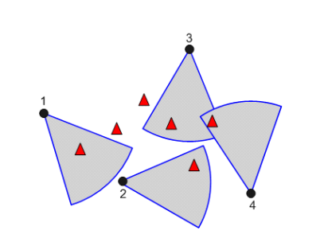

Fig 1: A random deployment

The solution to coverage problem focuses on two aspects; maximization of the coverage area or maximization of the number of discrete targets covered using minimal number of activated sensors at any instance. The process of selecting a sensor usually follows two steps; (i) selecting a sensor and, (ii) fixing its orientation. The process is proven to be an NP-complete problem. Therefore, to get a near optimal solution in polynomial time, we provide several heuristics in this work. Most of the existing works on directional sensor networks are implemented using Greedy approach. However, although a greedy approach can provide near optimal solution in most of the cases, there are many cases where it fails. Another issue with greedy approach is that the process of selecting a sensor and fixing its orientation is merged together. Splitting these two steps can provide more flexibility in developing many heuristics as we demonstrate in this thesis.

Unlike existing works, in this work we took an unorthodox approach for the problem formulation and in providing necessary solutions. We model the problem using graph theoretic approach so that one can have the opportunities to experiment with already-known graph algorithms having polynomial time complexity. We develop a weighted multi graph from the configurations of the sensors and targets that we term as a ‘conflict graph’. Using the information available from the conflict graph, we can easily develop different heuristics for selecting a sensor. Then we fix the orientation of the chosen sensor greedily. We have considered a random deployment environment since deterministic deployment is impractical. In inclement scenario, random deployment (see fig. 1) is more suitable. Here, a fixed number of targets and sensors are randomly deployed. The locations of all the targets are known to each sensor. Thus, each sensor knows which targets are covered by it in each orientation. Using this information we can develop a conflict graph where each sensor acts as a vertex and a weighted edge is added between two vertices if there is at least one common target covered by the both sensors for some orientation of each of them. The weight of each edge represents the number of common targets covered by the two sensors at their particular orientations. We then implement different heuristics using this conflict graph to solve the target coverage problem.

Besides, the problem can be viewed from two different perspectives; sensor-oriented and target-oriented. All the existing works are based on either one of them. In the proposed heuristics we have combined the merits of both the approaches to attain better performance.

In greedy approach, each selection affects the problem model in such a way so that it requires sorting of the remaining sensor-orientation pairs based on the number of targets covered by them. But conflict graph approach localizes this effect of sensor selection within the neighboring sensors only. So, conflict graph approach has an upper hand over greedy approach with respect to time complexity. Besides, most visual sensor networks (VSN) are over-provisioned systems. Greedy approach performs well for under provisioned systems, but performs poorly in an over-provisioned system. The proposed conflict graph approach provides a way around this drawback of the greedy approach.

1. Background & Problem Formulation

In this section at first we introduce the VSN with relevant parameters. Then we formalize the coverage problem that we are trying to solve in this thesis.

* 1. *Visual sensor network description and parameters*

The sensing region of a directional sensor (camera) can be characterized by its Field of View (FoV) defined as follows:

**Field of View (FoV):** The FoV of a camera is the extent of the observable/sensing region that can be captured at any given direction. Some cameras come with fixed-FoV and for some, FoVs are adjustable. The smart cameras used in current VSNs are known as Pan-Tilt-Zoom (PTZ) cameras where FoV can be self-adjusted in three dimensions: (i) horizontal movement in pan, (ii) vertical movement or tilt, and (iii) change in depth-of-field by changing zoom. In this thesis, we limit ourselves to pan-only cameras, i.e., we assume that a camera can move only in horizontal direction and its FoV is only described by its pan.

The pan of a camera is formally defined using the following two parameters:

(1) Rs: Maximum coverage range of the camera beyond which a target cannot be detected with acceptable accuracy in a binary detection test.

(2) θ: The maximum sensing/coverage angle of a camera in a certain direction. This angle is also known as Angle of View (AoV).

Thus, when a camera is oriented towards a particular direction, it can cover a circular sector (called a pan) defined by Rs and θ. We assume that every camera possesses a specific number of non-overlapping pans, of which, only one can be selected in a particular deployment. For example: a camera with FoV defined by $θ= \frac{π}{4}$ can pick any one of eight disjoint orientations. Fig. 2 depicts these parameters of camera coverage. Here, two cameras c1 and c2 have eight pans each and can be oriented towards any of these eight pans. We assume that cameras are homogeneous in terms of parameters. Position of a target and a sensor are expressed through Cartesian coordinates (x, y) in a two-dimensional plane. $\vec{d_{ik}}$ is a unit vector which cuts each pan (i.e., the sensing sector) into half representing the orientation of camera ci towards pan pk. is a vector in the direction from camera ci to target tj.

**Target in Sector (TIS) Test:** With TIS test (Ai and Abouzeid, 2006) one can verify whether a target tj is coverable by a given sensor ci. To conduct this test, at first we calculate the angle $φ_{ij}$ between camera orientation $\vec{d_{ik}}$ of pan pk and the target vector $\vec{v_{ij}}$.

$φ_{ij}=\cos^{-1}\left(\frac{\vec{d_{ik}}.\vec{v_{ij}}}{\left|\vec{d_{ik}}\right|\left|\vec{v_{ij}}\right|}\right)$ (1)

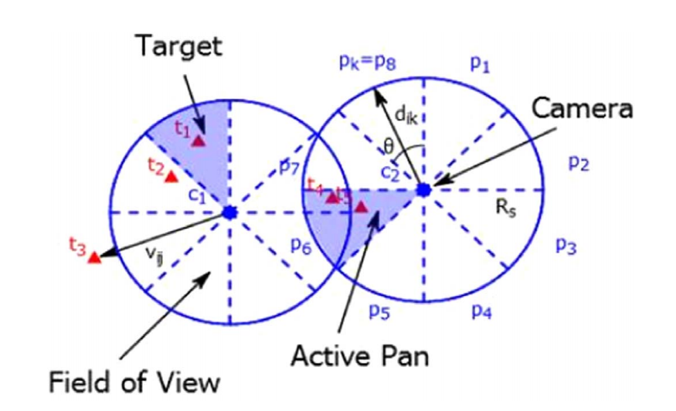

Fig 2: Coverage Parameters.

A target is coverable by a camera's FoV if the span of its FoV contains the target and the target is located within the sensing range of the camera. Geometrically, $\vec{d_{ik}}$ divides the pan pk into two equal halves and if a target is located in either of them, it is coverable by that camera on the pan pk. Thus, the angle $φ_{ij}$ needs to be less than or equal to half of the AoV, i.e., $φ_{ij} ≤ \frac{θ}{2}$. The other condition requires that the target has to be inside the maximum sensing range of the camera, i.e., $\left|v_{ij}\right|≤R_{s}$.

Conducting TIS tests over every pan pk of camera ci and every target tj, we can build a *binary coverage matrix $A_{N×Q}^{M}$* of the network comprising of M targets and N cameras with Q pans where an entry in the matrix can be calculated as:

(2)

* 1. *Problem formulation*

In this section we provide a formal description of the problem. Suppose we have a set of M randomly deployed targets $τ=\{t_{1}, t_{2}, …,t_{M}\}$ and a set of N homogeneous directional cameras $C=\{c_{1}, c_{2}, …,c_{N}\}$, each of which can be (self) orientated towards one of the Q possible pans $ρ=\{p_{1}, p_{2}, …,p_{Q}\}$. Let us define a tuple $〈c_{i}, p_{k}〉$ which is a camera-pan pair denoting a camera ci oriented towards pan pk for any $1≤i ≤N$ and $1≤k ≤Q$. Define a function $F(〈c_{i}, p_{k}〉)$ which returns the set of targets covered by the tuple $〈c_{i}, p_{k}〉$.

Suppose δ is the set of tuples that can cover at least one target, i.e.,

$$δ=\left\{〈c_{i}, p_{k}〉:\left|F\left(〈c_{i}, p_{k}〉\right)\right|>0\right\} i ϵ \left[1, N\right];k ϵ \left[1, Q\right];$$

The goal is to find a subset $δ^{'} ⊆ δ$ such that $\left|δ^{'}\right|$ is the minimum among all cardinalities of possible subsets of δ, and the quantity $\left|\bigcup_{〈c_{i}, p_{k}〉 ϵ δ^{'}}{F\left(〈c_{i}, p_{k}〉\right)}\right|$ gets maximized.

In other words, we seek to find orientations of minimum number of cameras to cover maximum number of targets which is also traditionally known as *Maximum Coverage with Minimum Sensors* (MCMS) problem.

1. Literature Review

Extensive works have been done over the past years in the area of wireless sensor networks for isotropic sensors. Only a few works are done with directional sensors. Generally, directional sensors are considered as visual sensors since they can sense only along a particular direction at any time. The primary goals of the research works in the area of VSN are design issues related to optimal placement and orientation of the visual sensors, energy efficient scheduling techniques to increase network lifetime, cost-effective transmission system for obtained sensor data, and fault tolerant network design to attain secured connectivity of the network. Yap and Yen (2014) have worked on these design issues. Liu et al. (2016) have done a comprehensive survey on different design aspects of VSN.

There has been some works regarding optimal placement and orientation of sensors to achieve some predefined goals. Chakrabarty et al. (2002) investigated on optimal placement problem considering the deployment area as a grid of coordinates. Only one visual sensor can be placed at a coordinate within the grid. They designed an Integer Linear Programming (ILP) model for solving small scale instances of the problem and for solving large scale instances, followed a Divide and Conquer approach. Horster and Lienhart (2006) devised a rank based greedy heuristic for placing the sensors where rank of sensor was calculated based on its cost and achievable target coverage. Sensor placement is a very important problem for VSNs. But it this thesis, we only focus on the problem of selection and orientation of the randomly deployed sensors.

In a randomly deployed environment, it is required to keep the number of active sensors at a time to a minimum due to limitation on energy consumption. So, the most important question in this context is how to select the sensors in an appropriate manner? The solution to this problem can be viewed from two directions: - (i) sensor-oriented approach, and (ii) target-oriented approach. There has been several works focusing on these two approaches. All of them aimed at maximizing target coverage with minimum number of sensors. Ai and Abouzeid (2006) proposed an ILP formulation that gave an exact optimal solution to this MCMS problem. But it is not suitable for large-scale scenario due to its high computational complexity and low computational capabilities of the deployed sensors. As a solution to this issue they proposed a Centralized Greedy Algorithm (CGA) and a Distributed Greedy Algorithm (DGA). DGA was introduced to achieve scalability in place of CGA. But CGA had some shortcomings in case of resolving tie between sensors. To come round the shortcomings of CGA, Munishwar and Abu-Ghazaleh (2013) proposed another heuristic based on greedy approach. They called it Centralized Force-directed Algorithm (CFA). The modification they made was that if a sensor covered some targets in only one pan, that sensor is selected first. So, they created a way to assign priority to each sensor pans. Instead of activating a sensor having maximum number of uncovered targets in some pans, they decided to activate the sensor having targets only in a single pan first and cover those targets. To find out such sensors, they introduced a concept, force which is the measurement of priority assigned to each pan. The force of a sensor-pan pair is the ratio of coverable targets in that pan of the sensor to the total number of uncovered targets available in all pans of that sensor. The higher the value of force, the higher is the priority. The value of force equal to 1 indicated that the sensor covered targets only in that pan and subsequently got selected first. Munishwar et al. (2011) also suggested a distributed algorithm to achieve coverage maximization. Here, they overlooked the idea of minimizing active sensors. Initially, all sensors assign a unique priority value by themselves. Then each sensor detects the total number of targets it can cover in each direction and orients itself to the direction of maximum target coverage. This orientation information is exchanged among the sensors located within twice of the sensing range. If there is more than one sensor covering a particular region, the orientation of the highest priority sensor prevails. For assigning priority they proposed two approaches: - (i) an area based approach, and (ii) a target based approach. In area based approach higher priority is assigned to the sensor with lower degrees of overlap in coverage with other sensors. In target based approach, a sensor’s priority is higher if it has lower number of useful pans, in other words, it has coverable targets in fewer pans than other sensors. All research works discussed till now are based on sensor oriented approach.

There has been works on target oriented approach too. H. Zannat et al. (2016) proposed three different heuristics for target oriented approach. The proposed algorithms are Greedy Target Oriented Heuristic (GTOH), Pure Target Oriented Heuristic (PTOH), and Hybrid Target Oriented Heuristic (HTOH). This approach differs from sensor oriented approach in a very vital aspect. In sensor oriented approach, priority is assigned to sensor and all targets are treated equally. But here, targets are assigned some priority and in each iteration, higher priority targets are selected and a sensor-pan pair is assigned to it. In GTOH, targets coverable by a single sensor (lonely targets) is given the highest priority. However, targets coverable by more than one sensors are assigned equal priority without any consideration of number of sensors covering them. PTOH differs from GTOH in the weight assignment of targets and the sensor selection criteria at each iteration. HTOH combines the ideas of both GTOH and PTOH. The weight assignment of targets and rank calculation of sensor-pan pairs are similar to PTOH. But the rule for selecting sensor-pan pairs follows GTOH.

There has been a few works (Fusco and Gupta, 2009; Lu and Yu, 2014; Costa et al., 2014) focusing on k-coverage problem in directional sensor networks. These works are designed to allow redundant sensor activation so that multiple coverage can be ensured to all or prioritized targets. Costa et al. (2014) proposed an algorithm to achieve a high level of monitoring redundancy for some critical targets by concurrently viewing them using more than one visual sensor. The optimal solution to k-coverage problem has been proved to be NP-hard by Fusco and Gupta (2009). They provided a centralized greedy solution to the problem assuming that each sensor has overlapping pans instead of discrete pans. They also proposed approximation algorithms to some related problems on directional sensors: (i) orient all the given sensors in order to maximize coverage, (ii) place and orient a minimum number of sensors in order to cover the given area, and (iii) place and orient the given number of sensors to maximize the area covered. Malek et al. (2016) identified a novel issue called coverage balancing in k-coverage problem and provided centralized solutions to jointly solve k-coverage and coverage balancing. The solutions to k-coverage problems address fault tolerance issue which is beyond the scope of this paper and we limit ourselves only to single coverage of each target.

1. Motivation

All the related works are formulated based on greedy approach. They have designed their solution either in a sensor-oriented or a target-oriented way. Each of the existing algorithm fuse the selection of a sensor and fixing its orientation into a single step. Most of them focused only on target coverage maximization, giving less priority towards sensor minimization. All of the discussed works have another limitation in the process of eliminating targets which get covered at each iteration after the selection of a sensor. To remove targets that are covered at the current selection, they required to search the total set of inactive sensors each time.

In this thesis we are proposing to model the problem in graph theoretic approach which will add a new dimension to this problem. After modeling the problem we can apply well known graph algorithms and use graph properties to find better heuristics as the solution of the problem. Again in the proposed system, the single step of selecting the sensor and orientation is split into two steps of selecting the sensor and then selecting the best orientation of the selected sensor. The traditional methods what we have studied or discussed is either sensor-oriented or target-oriented. When we complete modeling the problem using graphs, we can implement both at the same time depending on different heuristics. As in the previous methods we have no prior information about which targets are covered by more than one sensor, when we have to remove the already covered targets from the target set of the remaining sensor sets after selection of a sensor we have to search all the sensors and each of their orientations. But in our proposed one, this search will be more localized and will involve search only through the neighboring sensors which has potential to reduce the runtime.

1. Work Plan

First of all, we have to model the problem in graph theoretic approach. The nodes of the graph will be the sensors deployed. The edges between two sensors will be on the basis of the targets in conflict. The targets which are covered by more than one sensor are the conflicted ones. For each orientation pair between two sensors, there will be an edge if there are one or more conflicted targets. That means each edge actually represents the conflict or coverage overlap between the orientations of two sensors. The graph will be a weighted multi-graph as there may be more than one edge between two nodes or sensors. The weight of the edges will be the total number of conflicts between an orientation pair of them. So, we can call the graph a *conflict graph*. Again, there will be self-edges in all sensors. We can name them as shadow edges which will be created for each orientations of a sensor. The weight of these shadow edges will be different from the other edges. The weight here will represent the total number of non-conflicted or lonely targets in each orientation of a sensor. In target-oriented method, the lonely targets are looked into at first whereas in our approach without looking at the targets we can keep track of the lonely targets. In that sense, we can incorporate the merits of target-oriented method in our approach.

After completion of modeling the graph, we can get the information of total conflicts of all the sensors and also the total number of non-conflicted or lonely targets. This information would allow applying different heuristics for selecting the sensors and their orientations.

Unlike traditional methods, we are spitting the selection of sensor and its orientation in two steps. At first we will select the sensor from the modeled graph in one step and then in the next step, we will select the orientation from that selected sensor. For selecting the sensor, we can use the heuristic of total maximum number of conflicts or the total minimum number of conflicts. We can also the select that sensor which one covers the maximum lonely targets (which information we will get from the summation over the shadow edges of a sensor). If we select the sensors with the total maximum conflict, we are actually resolving the conflicts among the conflicted sensors which will allow the remaining sensors involved in the conflict to focus more on the lonely targets.

Again if the total number of targets covered by a sensor is much more than the number of conflicts, then we are sure about the fact that the sensor is covering mostly the lonely targets. If we select those sensors, then actually this will be more likely target-oriented. After selection of the sensor, for selecting the orientation of that selected sensor we can greedily take that orientation which will cover the most targets. Then the selection process of orientation will be in sensor-oriented greedy approach. When we have the conflict graph in our hand, we can also apply more different heuristics to find out better solutions for different scenarios.

1. Comparison of different heuristics

In this section, we will give a comparative analysis among the existing heuristics and one of our proposed heuristics with the help of an example scenario.

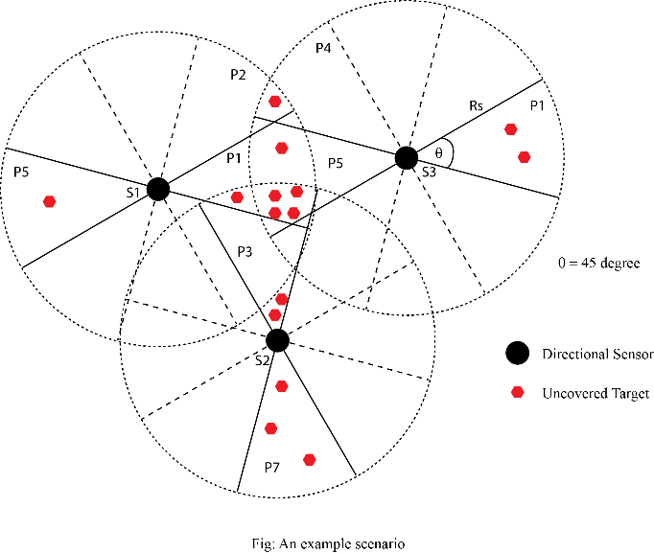

Here, three sensors s1, s2, and s3 are deployed. The sensing range is Rs. AoV is fixed at 45 degree. So, each sensor has eight disjoint pans. Total fifteen targets are randomly deployed. The size of the coverage set of each sensor-orientation pair is as follows:

* 1. *Greedy solution*

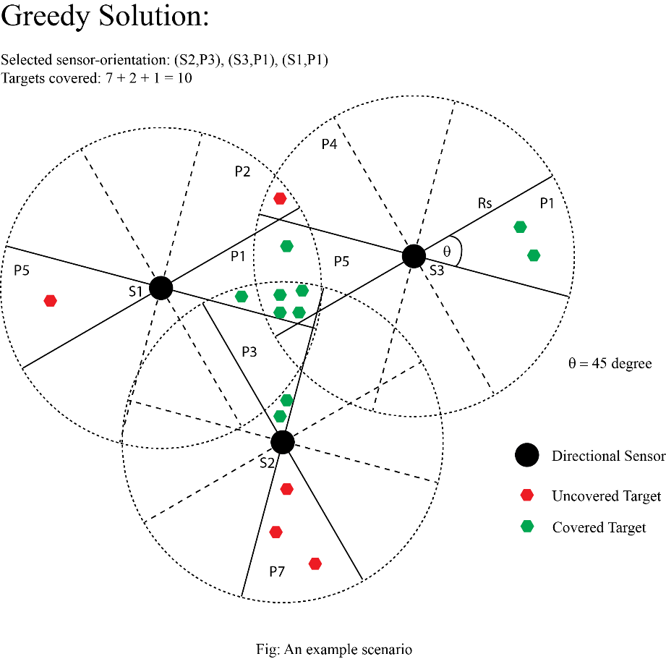

* 1. *Target-oriented solution*

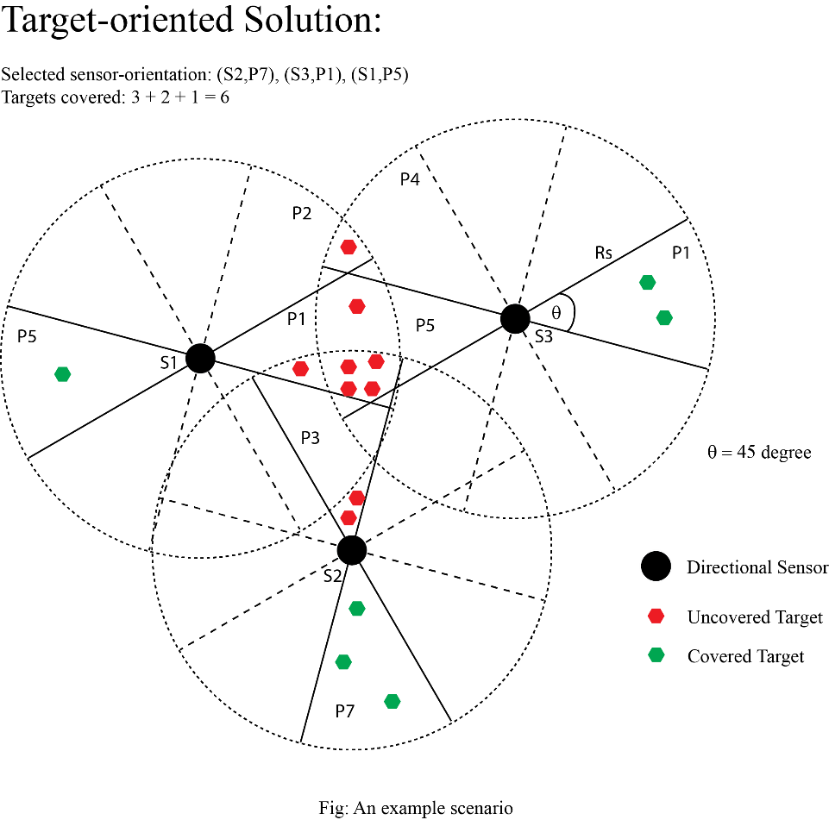

* 1. *Conflict graph: Total max. conflict*

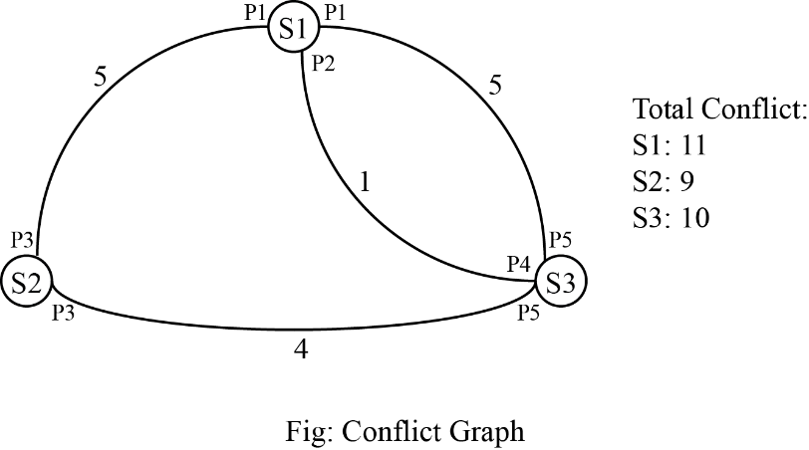

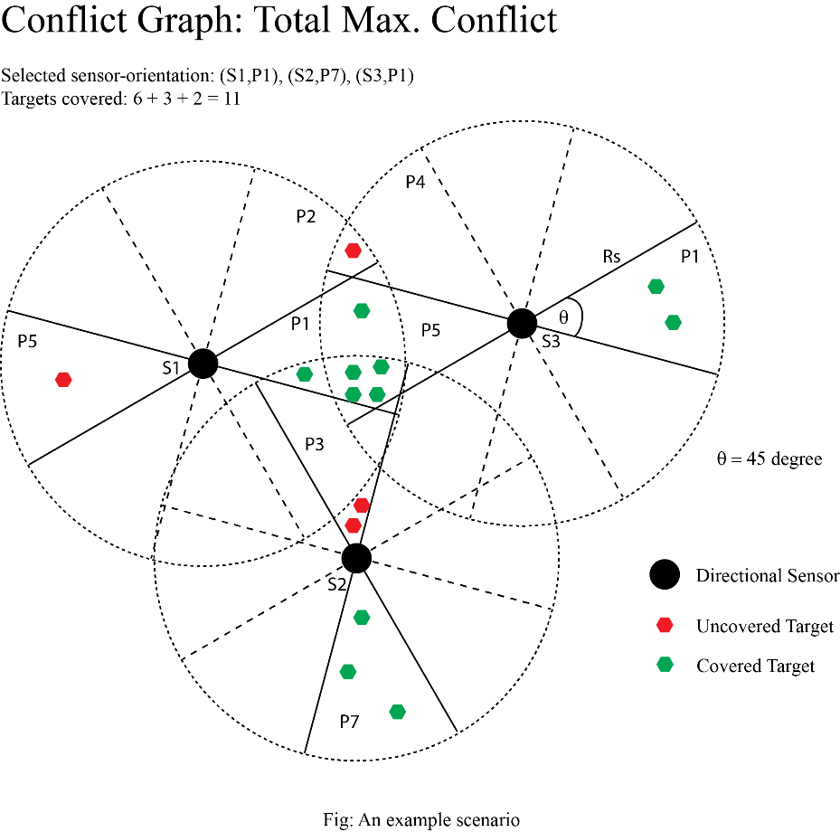

1. Conclusion

We present a graph theoretic approach to solve the maximum target coverage problem using minimum sensors. The main challenge of this work will be to successfully model the conflict graph before we devise heuristics to solve the problem. Once conflict graphs are successfully derived, formulating different heuristics using the devised graph model would be the next step which is also a paramount task. So, our future plan includes the formulation of different heuristics which will be applied to our graph model with a view to generate better solutions for different scenarios than those of the existing ones. Finally, we will evaluate performance of the new heuristics on different metrics in contrast with the existing ones.

As a concluding remark, we would like to mention that the proposed work is looking into the problem in a new dimension by introducing the graph theoretic approach. To the best of our knowledge the graph theoretic approach has not been utilized to solve this problem. Therefore, the proposed model has much potential to open up new opportunities for finding better solutions.

1. References

… [will be added later on]